COVID 19 USING COGNOS

INTRODUCTION

[IBM has developed a new, interactive global dashboard to show the spread of COVID-19 across the world using IBM Cognos Analytics](https://www.ibm.com/blog/creating-trusted-covid-19-data-for-communities/) .The COVID-19 data reflected in this dashboard is pulled from state and local governments and the World Health Organization. The dashboard is designed to give the general public, researchers and even government officials detailed, localized and current information about COVID-19. The dashboard provides multiple ways to summarize data. For example, users can view statistics on active cases, deaths and recovered patients by country; number of cases by region; and historical trends. [IBM is also considering developing additional tools for researchers](https://www.ibm.com/blog/creating-trusted-covid-19-data-for-communities/) .

USAGE OF COGNOS IN ANALYTICS

* Interactive Visualizations: Users can interact with the visualizations, such as zooming in on specific regions, selecting data points for detailed information, and comparing trends over time.
* Data Collection and Integration:   [Data integration enables you to easily access all of the data you need to make informed business decisions and allows you to transform and combine data sources for accurate analysis](https://www.domo.com/learn/article/data-integration-in-business-intelligence). [The insights that result from having your data contextualized are invaluable because they allow business users to quickly determine what actions should be taken](https://www.domo.com/learn/article/data-integration-in-business-intelligence).
* Sharing Insights: Cognos Analytics provides several ways to share insights and analysis results with others. [we can share insights with or without a visualization from the Assistant via email, Slack, and Microsoft Teams](https://www.ibm.com/docs/en/cognos-analytics/12.0.0?topic=assistant-share-narrative-insights-from) . [Your administrator must configure a mail server and/or a collaboration platform before you can use this feature](https://www.ibm.com/docs/en/cognos-analytics/12.0.0?topic=assistant-share-narrative-insights-from) . [You can also share dashboard content by creating a URL to the content, creating code that can be embedded in a webpage, and creating a PDF of the dashboard](https://mediacenter.ibm.com/media/IBM+Cognos+Analytics+with+Watson+-+How+to+share+dashboard+content/1_bib2p456) .

KEY TOOLS IN COGNOS

NYGH successfully used IBM Cognos Analytics software to measure and report its QBPs, developing and delivering reports for individual metrics such as cost per case, length of stay, patient age and so on. However, the hospital needed a way to dynamically visualize the relationships between variables on the fly, instead of creating a new report for each relationship Analysis. In 2017, the hospital engaged IBM to begin transforming its analytics infrastructure to provide a more powerful and flexible way to monitor QBP performance. The BI team needed to create a dynamic, real-time dashboard to track active cases and measure the impact of the pandemic on its service provision. Community transmission has a high impact on the hospital, we needed to be able to measure them in near real time.

* Faster Insights: AI-powered automation and insights in Cognos Analytics enable everyone in your organization to unlock the full potential of your data. The natural language AI assistant is always available to describe the data you need and let Cognos Analytics build stunning Data Visualizations.
* Data Calculation: In data analytics, the standard deviation and the sum of the mean squares (also known as the sum of squared deviations or variance) are two important statistical measures used to understand the variability within a data set.

1. Standard Deviation: The standard deviation measures the amount of variation or dispersion in a set of Data Points. It quantifies how individual data points deviate from the mean (average) of the data set. A higher standard deviation indicates greater variability, while a lower standard deviation suggests that data points are closer to the mean. The formula for calculating the standard deviation is the square root of the variance:

Standard Deviation (σ) = √Variance

1. Sum of Mean Squares (Variance): The sum of mean squares (variance) is a measure of the average squared deviation of each data point from the mean of the data set. It provides insight into the spread or dispersion of data points around the mean.

The formula for calculating the variance is as follows:

Variance (σ^2) = Σ (xi - μ) ^2 / N

where:

- xi represents each data point.

- μ is the mean of the data set.

- N is the total number of data points.

These two measures help data analysts assess the variability and distribution of data, which can be crucial for making informed decisions and drawing meaningful insights from data sets.

RESULT

Dataset Link: <https://www.kaggle.com/datasets/chakradharmattapalli/covid-19-cases>

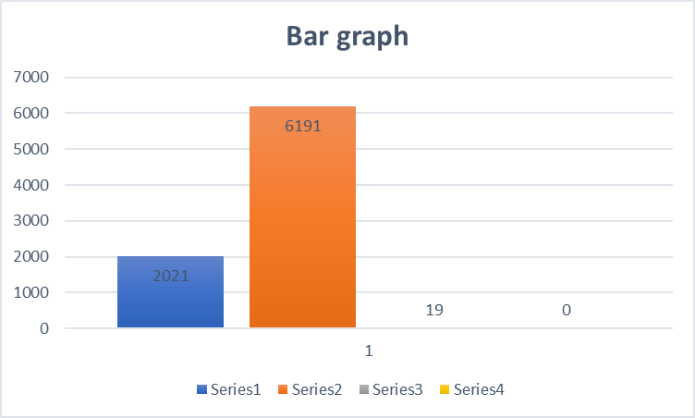

In this Bar graph, we can observe the Snapshot of covid -19 cases in different regions using Cognos. IBMers who are bringing change into the world helping cure diseases, clean our oceans and make technology work for good. Our people are what make us unique. Every individual from around the world with a quest for knowledge has a voice to add to our story.

CONCLUSION

COVID-19 pandemic has profoundly impacted the world in unprecedented ways. Through rigorous scientific research, global collaboration, and widespread vaccination efforts, we have made significant strides in understanding and mitigating the virus's effects. While challenges remain, our collective resilience and commitment to public health have shown that humanity can overcome even the most daunting crises. It is crucial to continue monitoring the situation, adapting our strategies, and maintaining the spirit of cooperation that has brought us this far. Together, we can work towards a healthier and more resilient future.